SAP 4 – Sales
MGIS 4580 – Fall 2023 DELIVERABLE

Check Inventory Levels

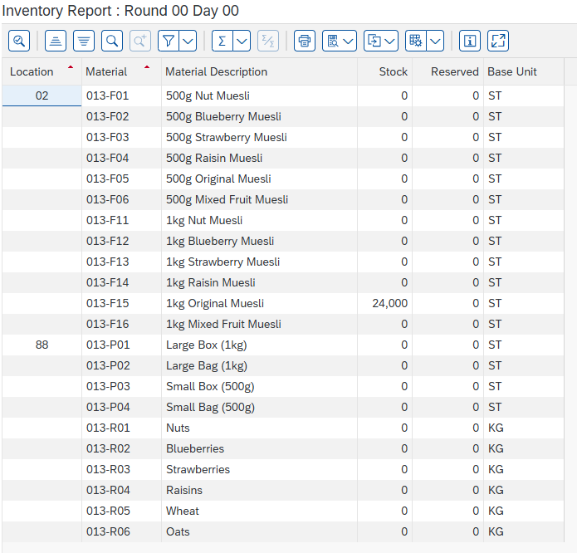

Create Sales Order
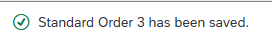

Create Outbound Delivery

Check Inventory Levels

Create Billing Document

Post Incoming Payment

View Customer Balance

